USER ACCEPTANCE TESTING (UAT)
BLOG NEST
Date: 23 September 2026
Team ID | SWTID-2026-9317
Project Name | Blog Nest
Maximum Marks | 4 Marks
Date | 24/9/2026

Project Overview
Project Name: Blog Nest
Project Description: A blogging platform for creating, publishing, reading, searching and sharing blog posts.
Project Version: 1.0
Testing Period: ________________ to ________________

Testing Scope
Features and functionalities to be tested:
- User login and registration
- Create and edit blog posts
- Publish blog posts
- Browse and search blogs
- Read blog content
- Share blog posts
- Basic content management
User requirements to be tested:
- User can access the platform
- User can create content
- User can publish and manage content
- Reader can find and read content
- User can share content
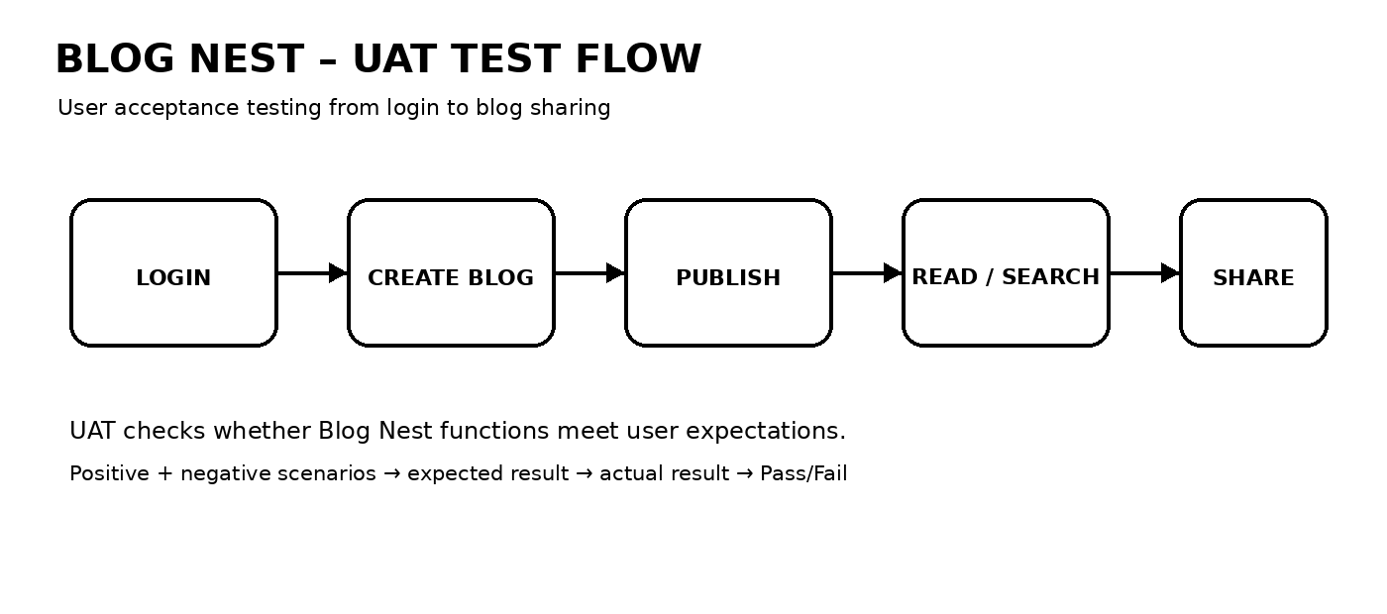

Test Cases
Test Case ID | Test Scenario | Test Steps | Expected Result | Actual Result | Pass/Fail
TC-001 | User login | 1. Open Blog Nest  2. Enter valid credentials  3. Click Login | User successfully logs in | ________________ | ____
TC-002 | Invalid login | 1. Open login  2. Enter invalid credentials  3. Click Login | Error message is displayed | ________________ | ____
TC-003 | Create blog | 1. Login  2. Open Create Blog  3. Enter title/content  4. Save | Blog is created successfully | ________________ | ____
TC-004 | Publish blog | 1. Open saved blog  2. Click Publish | Blog becomes available to readers | ________________ | ____
TC-005 | Search blog | 1. Enter a topic in search  2. Submit search | Relevant blogs are displayed | ________________ | ____
TC-006 | Read blog | 1. Select a blog  2. Open the post | Selected blog content is displayed | ________________ | ____
TC-007 | Share blog | 1. Open a blog  2. Select Share | Blog sharing option works correctly | ________________ | ____
TC-008 | Empty blog submission | 1. Open Create Blog  2. Leave required fields empty  3. Submit | Validation message is displayed | ________________ | ____

Bug Tracking
Bug ID | Bug Description | Steps to Reproduce | Severity | Status | Additional Feedback
BG-001 | ________________ | 1. __________  2. __________  3. __________ | Low / Medium / High | Open / In Progress / Closed | ________________
BG-002 | ________________ | 1. __________  2. __________  3. __________ | Low / Medium / High | Open / In Progress / Closed | ________________

Sign-off
Tester Name: ______________________________
Date: ______________________________
Signature: ______________________________

Notes
- Ensure that all test cases cover both positive and negative scenarios.
- Testers should provide detailed feedback and suggestions for improvement.
- Bug tracking should include severity, status and steps to reproduce.
- Obtain sign-off from the project manager and product owner before deployment.

Format and sections adapted from the uploaded User Acceptance Testing (UAT) Template.

